Project: Steganography
Difficulty: Level 1

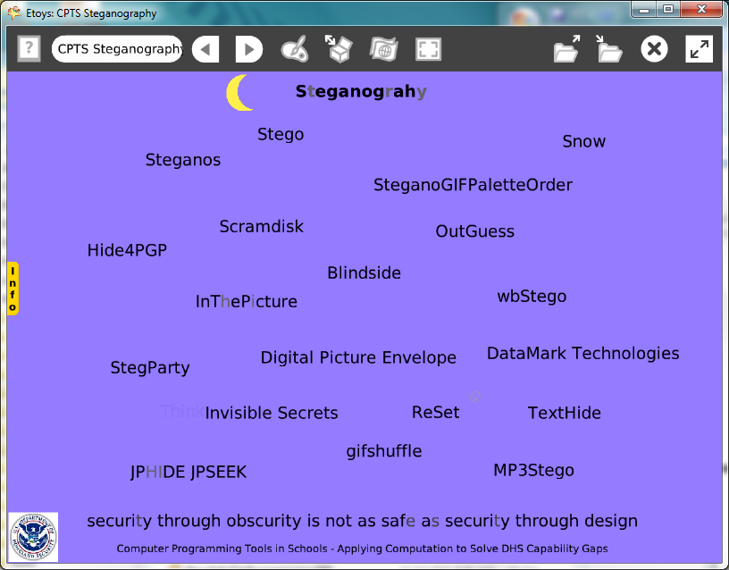

Time: Three 45 minute labs

Challenge:
Employ several kinds of steganography in a project. The example project has hidden messages and includes several web sites for research. Include information about cryptography techniques or web sites in the project or in a flap.

Programming:
Basic tiles for x and y locations and motion, conditional statements, ticking and normal scripts, a button to fire a script and clear all pen trails command. There are no Quick Guides for the Scripting category of tiles. The tiles do have help balloons that are a useful starting place for experiments.

Things you’ll need to know:
Quick Guides
- Paint Tools/ All
- Halo Handles/All
- Supplies: Text, Add a New Flap
- Script Tiles: X and Y Tiles, Tests, Scale Factor, Pen Use
- Menus: Normal Ticking, Button Fires a Script,

Things to think about:
Code breaker’s dilemma:
- Did you find eight hidden messages in the example project?
- Are eight messages hidden or is the question another form of cryptography?
- Telling how many messages are hidden might be a hint to encourage you to find all of them.
- Or, it might be a trick and that is not how many messages there are in this project.
- How much time and effort is wasted checking for concealed messages?

Extensions:
- Experiment with several cryptography techniques in small projects.

NETS for Students:
http://www.iste.org/standards/nets-for-students/nets-student-standards-2007.aspx
1. Creativity and Innovation: a, b, c
2. Communication and Collaboration: a, b
3. Research and Information Fluency: b, c
4. Critical Thinking, Problem Solving, and Decision Making: a, b, c, d
5. Digital Citizenship: a
6. Technology Operations and Concepts: a, b, c, d

CSTA:
CSTA Level II: Objectives and Outline
http://csta.acm.org/Curriculum/sub/CurrFiles/L2-Objectives-and-Outlines.pdf
Level II objectives for middle school students are furthered through studying a programming language well enough that the student is proficient with it. Whether the language is Etoys, StarLogo TNG, or Scratch, it is the ability to use the language to express ideas that is valuable. A student skillful enough to use any programming language to express ideas, solve problems, model behaviors, simulate data, or to educate or entertain is an entitled person in today’s society.
Topics of particular note are:
Topic 2: Problem Solving
Topic 6: Connections between Mathematics and Computer Science
Topic 11: Programming Languages
Topic 13: Multimedia

Common Core Standards Mathematics:
http://www.corestandards.org/the-standards/mathematics
6. NS.6, 6. EE.2

Teacher Notes:
Materials: Provide students with several web site links to research steganography. There are many kinds more than the ones that are listed in the project. N.B. ReSet is not a kind of steganography; it is a script button that erases a special effect in the project.

Comments: Objects - Scripts – Decisions
These scripts are not difficult but planning how to conceal messages will take time.

Example Scripts:

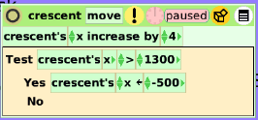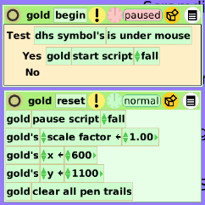

Student Notes:
Code breaker’s dilemma:
- Did you find eight hidden messages in the example project?
- Are eight messages hidden or is the question another form of cryptography?
- Telling how many messages are hidden might be a hint to encourage you to find all of them.
- Or, it might be a trick and that is not how many messages there are in this project.
- How much time and effort is wasted checking for concealed messages?

